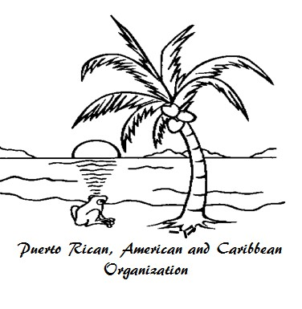
13th Annual
Hispanic Festival
August 17, 2013 Dayton, Ohio
11:00 a.m. to 11:00 p.m.
Puerto Rican, American and Caribbean Organization (PACO)
P.O. Box 31043, Dayton, Ohio, 45437-0043

**Please read the below for complete festival information! ¡Por favor lea toda la información!**
The Puerto Rican, American and Caribbean Organization (PACO) is a non-profit organization dedicated to the success of the Hispanic community. PACO and Five Rivers MetroParks invite you to join the celebration on Saturday, August 17, 2013 in Dayton, Ohio at RiverScape. Participation terms and information for vendors is provided below.

Food Vendor Participation Fee
• Festival application and participation fee of $300 must be received by June 30, 2013. Checks received before this date will get a discounted fee of $225. Vendors who send checks after this date will be charged regular fee.
• Participation fee will include approximately a 10’ x 12’ space at the festival per booth, kiosk or trailer.
• Additional Costs: Tents $50 each, Tables $10 each, and Chairs $5.
• Provide a diagram or dimensions of your booth, kiosk or trailer.
• Money is non-refundable and the festival will go on rain or shine.
• No water and carbonated beverages will be sold by food vendors.

Food Vendor Guidelines
• PACO has exclusive beverage rights; water and carbonated beverages (soda/pop) will not be
served or sold at the festival by any vendor.
• Space is limited and applications will be accepted on a first-response basis. The PACO has the right to reject any application.
• Entire food vendor space needs to be covered in roofing/tar paper.
• The use of sidewalks for cooking of any type will not be permitted.
• Any vendors caught dumping grease or grey water will be suspended from any further sales at the festival and suspended from ever doing business at MetroParks facilities.
• Lights are required during evening hours. Light bulbs must be shielded to prevent shattering.
• Vendors are required to obtain the proper permit. Apply 10-days prior to the event. Contact the Montgomery County Combined Health District http://www.phdmc.org/environment/food to obtain an Application for a License to Conduct a Temporary Food Service Operation or call (937) 225-4460. http://www.phdmc.org/images/uploads/Temporary_Food_Service_Application_Packet.pdf

Vendor Set-Up
Vendors will be allowed to set-up on the Friday evening prior to the festival from 6:00 – 8:00 p.m.
(overnight security will be provided) or Saturday morning, the day of the festival, after 7:00 a.m. The festival will be open to the public from 11:00 a.m. to 11:00 p.m.

IMPORTANT! All vendors must be ready 1 hour before event time (10:00 am). No vehicles will be allowed inside the festival footprint starting one hour before the event and ending when the Rangers give the ‘all clear’ following the event (usually 30 minutes after close).

Festival Address
111 East Monument Avenue, Dayton Ohio, 45402. The festival is free to the public. For additional information email DaytonPACO@gmail.com or visit the PACO Website: www.pacodayton.org.
Food Vendor Application
PACO Hispanic Festival - Dayton, Ohio
** August 17, 2013 **
Application & payment must be received by June 30, 2013 for the discounted price to be charged.

Contact Name:

Name of Booth:

Phone(s) & Email:

Complete Mailing Address:

List Menu Items you will be selling during the festival:

1. 4. 7.

2. 5. 8.

3. 6. 9.

Festival Requirements
$ _______ Participation Fee ($225 by June 30, 2013; $300 if application received after this date)
$ _______ Tent 10’x 10’ ($50 each) Number of Tents requested:
$ Table 6ft. ($10 each) Number of Tables requested:
$ _______ Chair ($5 each) Number of Chairs requested:

$ Total Amount

Electric Requirements
110 or 220 (please circle amps)

List Appliance(s) & Watts/Amps Below

1.
3.
5.

2.
4.
6.

If you are bringing a trailer, provide the dimensions below and layout on the back side:

I have read and accept the Food Vendor Agreement/Guidelines and agree to abide by them. I understand that I enter the festival at my own risk. RiverScape MetroPark and PACO are not responsible for damage, theft, or loss of my property.
Signature & Date

Mail signed application & check or money order to:
PACO, P.O. Box 31043, Dayton, OH 45437-0043

